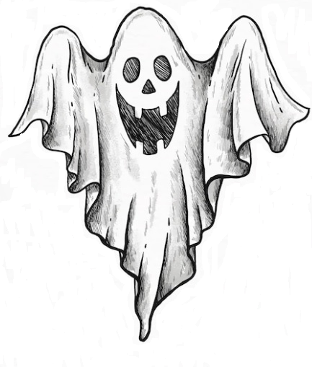**25th Annual 5K BOO RUN**

**October 26, 2024**

Sponsor Form

Sponsor’s Name: ____________________________________________________

Contact Person: _____________________________________________________

Phone: _______________ E-Mail: _______________________________________

Address: ____________________________________________________________

City: _______________________________ State: _________ Zip: ____________

Sponsor’s Donation: ________________________________________________

Event Member Signature: __________________________________________

Sponsor’s Signature: _______________________________________________

$2000 Title Sponsor (Only 1 Title Sponsor) – Recognition as Race Title Sponsor Before Awards Ceremony

* Logo Across Top of Shirt Back; - Company Banner at Finish Line; - 2 Shirts Per Sponsoring Business; - 8 Free Participant Registrations (with shirts and bags)

$1000 Title Sponsor (if no $2000 Sponsor) - Logo on Shirt back; - Company Banner @ Finish Line;

- 2 Shirts Per Sponsoring Business; - 6 Free Participant Registrations (with shirts and bags)

$500 Business Sponsor - Logo on Shirt Back; - Company Banner @ Finish Line; - 2 Shirts Per Sponsoring

Business; - 4 Free Participant Registrations (with shirts and bags)

$250 Business Sponsor - Logo on Shirt Back; - 2 Shirts Per Sponsoring Business; - 2 Free Participant

Registrations (with shirts and bags)

**BE SURE TO LIST SPONSOR SHIRT SIZES ON BACK OF FORM**

Make checks payable to Flowery Branch Masonic Lodge #212 and mail to

P.O. Box 624, Flowery Branch, Ga. 30542.

Flowery Branch Masonic Lodge #212 Tax ID 58-1898203.

**Please supply company logo in .EPS of .AI format (preferably)**

Promote your business by supplying sale papers, discount coupons,

Hand bills or samples that can be stuffed into the runner race packets.